A

PROJECT REPORT

ON

PARKING-AT-TIPS

Submitted in partial fulfilment for the award of

Post Graduate Diploma in Advance Computing

(PG-DAC) from

INSTITUTE OF EMERGING TECHNOLOGIES

# Authorized Training Centre



Under the Guidance of

Prof. Rahul Bilani

BY

Bandgar Prashant : 230945920009

Devkar Abhijit : 230945920018

Bhavesh Gharat:230945920027

Patil Sayali : 230945920066

Sourabh Lowanshi: 230945920100



# CERTIFICATE

This is to certify that the project report entitled Parking-At-Tips is a bonfire work carried out by PRASHANT BANDGAR, ABHIJIT DEVKAR, SAYALI PATIL, BHAVESH GHARAT AND SOURABH LOWANSHI and submitted in partial fulfilment of the requirement for the C-DAC ACTS, PG-DAC course in Institute of Emerging Technology in the batch of SEPTEMBER 2023.

Course Coordinator External Examiner

ACKNOWLEDGEMENT

This project Parking-At-Tips was a great learning experience for us and we are submitting this work to Advanced Computing Training School (CDAC).

We are very glad to mention Prof. Sampada Tarare for her valuable guidance to work on this project. Her guidance and support helped us to overcome various obstacles and intricacies during the course of project work.

Our most heart full thanks go to Mr. Sangram Patil (Director, IET)who gave all the required support and kind coordination to provide all the necessities like required hardware, internet facility, and extra lab hours to complete the project and throughout the course up to the last day here in C-DAC ACTS, Pune.

Sign of students

Prashant Bandgar (230945920009)

Devkar Abhijit (230945920018)

Gharat Bhavesh (230945920027)

Patil Sayali (230945920066)

Sourabh Lowanshi (230945920100)

## Abstract

The Smart Parking System is an innovative solution designed to address the growing parking challenges in urban areas. This project leverages cutting-edge technologies like ReactJS, Spring Boot, and MySQL to create a user-friendly application that enables users to find parking slots in their required area efficiently.

The system employs ReactJS, a popular JavaScript library for building user interfaces, to develop a responsive and intuitive front-end interface. Users can easily navigate the application and access key features such as searching for available parking slots, viewing parking slot details, and making reservations.

Spring Boot, a powerful framework for building Java-based applications, is utilized to develop the back-end of the system. It provides a robust and scalable architecture that supports various functionalities such as user authentication, parking slot management, and database operations.

MySQL, a widely-used relational database management system, is employed to store and manage data related to parking slots, user information, and reservations. The system ensures data integrity, security, and efficient retrieval of information.

The Smart Parking System offers several benefits, including improved parking management, reduced traffic congestion, and enhanced user experience. It is a comprehensive solution that addresses the complex challenges of urban parking and provides a seamless experience for both users and administrators.

Index

|  |  |  |
| --- | --- | --- |
| **Sr. No.** | **Title** | **Page No.** |
| 1 | Introduction | 6 |
| 2 | Problem Definition & Scope | 7 |
| 2.1 | Problem Definition | 7 |
| 2.2 | Goals & Objectives | 8 |
| 2.3 | Major Constraints& Outcomes | 9 |
| 3 | Software Requirement Specification | 10 |
| 3.1 | Purpose | 10 |
| 3.2 | Scope | 10 |
| 3.3 | Functional & Non-functional Requirements | 11 |
| 4 | System Modules | 13 |
| 5 | Performance-Requirements | 14 |
| 5.1 | H/W Requirements & S/W Requirements | 14 |
| 6 | UML Diagram | 15 |
| 6.1 | DFD | 15 |
| 6.2 | ERD | 16 |
| 6.3 | Use case diagram | 17 |
| 6.4 | Class Diagram | 18 |
| 6.5 | Deployment diagram | 18 |
| 7 | Application Screenshots | 19 |
| 8 | References | 27 |

### 

|  |
| --- |
| **1.Introduction**  **1.1 Overview**  The numbers of personal vehicles usage is increasing day by day. Due to this searching for a vacant parking area during peak hours is not only time-consuming but also results in wastage of fuel. The drivers keep searching for a proper parking lot that leads to increased traffic. Increasing volume of vehicular exhaust creates a negative impact on the environment. Hence reservation-based smart parking has become the need of the day.  At this time, most existing parking lots do not have a system in place. Most of them are managed by hand and are a bit ineffective. Every user's demand should be i. more efficient ii. Users friendly iii. They should provide more security. The idea behind our Web Application- “valid spot” is to help the user for online parking booking. The Smart Parking Application aims at helping users to find the most suitable area for parking , make reservations and extend them, if required. In this application user can view various parking areas also he can select it to view whether parking slot is available or not. If the parking slot is available in parking, then user can book it for some specific time slot also, this system provides an additional feature of cancelling the bookings. It also utilizes the open ground for parking with security. Thus, it is going to solve the parking and traffic problem. In this case, it is not necessary to use an extra expensive camera and scanner for verification. The smart parking system based on slot reservation is implemented, utilizing the Android application. The app having the features of slot allocation, by using the slot allocation method, user can reserve their own lowest-cost parking slot. It is an effective way in resolving the parking issues , which helps for traffic congestions and also provide the automated payment billing process. This work gets extended as a fully automated system using multilayer parking method. "Smart Parking" system in their portable devices.  **`** |

**2. Problem Definition and Scope**

**2.1. Problem Definition**

**Problem Statement:**

Urban areas face significant challenges related to parking, including congestion, pollution, and inefficient space utilization. Traditional parking systems often result in wasted time and fuel as drivers search for available parking spots. To address these issues, there is a need for a Smart Parking System that leverages technology to efficiently manage parking spaces and enhance the overall urban mobility experience.

**Key Objectives:**

**Optimize Space Utilization:** Develop a system that efficiently utilizes available parking spaces, minimizing empty spots and maximizing revenue generation for parking operators.

**Reduce Congestion:** Implement features that enable drivers to quickly locate and reserve parking spots, reducing traffic congestion and emissions caused by circling for parking.

**Improve User Experience:** Create a user-friendly interface accessible via mobile devices, allowing drivers to easily find, reserve, and pay for parking spaces.

**Enhance Safety and Security:** Incorporate features such as real-time monitoring, surveillance, and automated payment systems to enhance the safety and security of both vehicles and users.

**Promote Sustainability:** Integrate eco-friendly practices such as encouraging the use of electric vehicle charging stations and prioritizing parking for shared mobility options like carpooling or bike-sharing services.

**Key Features:**

**Real-Time Availability:** Utilize sensors or cameras to detect available parking spots and provide real-time updates to drivers via a mobile app or digital signage.

**Reservation System:** Allow drivers to reserve parking spaces in advance, reducing stress and uncertainty while optimizing space utilization.

**Payment Integration:** Implement seamless payment options, including mobile payment, contactless payment, or automatic billing linked to user accounts.

**Navigation Assistance:** Provide turn-by-turn navigation to guide drivers to their reserved parking spots efficiently.

**Data Analytics:** Collect and analyse parking data to identify usage patterns, optimize pricing strategies, and improve overall system performance.

**Integration with Urban Infrastructure**: Collaborate with local authorities and transportation agencies to integrate the smart parking system with existing urban infrastructure and public transportation networks.

**Challenges:**

**Infrastructure Integration:** Adapting existing parking infrastructure to accommodate sensor technology and communication systems.

**Data Privacy and Security:** Ensuring the protection of user data and preventing unauthorized access to sensitive information.

**User Adoption:** Educating and incentivizing drivers to use the smart parking system instead of traditional parking methods.

**Maintenance and Scalability:** Establishing protocols for system maintenance and scalability to accommodate future growth and technological advancements.

**Regulatory Compliance:** Ensuring compliance with local regulations and standards related to parking, privacy, and data management.

By addressing these challenges and implementing the outlined objectives and features, a Smart Parking System can significantly improve urban parking efficiency, reduce congestion, and enhance the overall urban mobility experience.

#### **2.2 Objectives**

The primary objective of a smart parking system web application is to streamline the parking experience for users and optimize the management of parking resources. Below are the key objectives:

**Efficient Parking Management**: The web application should provide a centralized platform for parking operators to manage parking spaces effectively. This includes monitoring occupancy levels, managing reservations, setting pricing policies, and generating reports for analysis and decision-making.

**Real-Time Availability Updates**: Users should be able to check the availability of parking spaces in real-time through the web application. This information can be displayed on a map interface, allowing users to quickly identify nearby parking options and make informed decisions.

**Reservation and Booking**: The web application should enable users to reserve parking spaces in advance, either for immediate or future use. Users should be able to specify their desired location, date, and duration of parking, with the option to modify or cancel reservations as needed.

**Seamless Payment Integration:** The web application should facilitate seamless payment processing for parking reservations. Users should be able to make payments securely using various payment methods, such as credit/debit cards, mobile wallets, or digital payment platforms.

**User Account Management:** The web application should support user account creation and management functionalities. Users should be able to create profiles, store payment information, view reservation history, and receive notifications related to their parking activities.

**Navigation Assistance:** Integrating navigation features into the web application can help users navigate to their reserved parking spaces efficiently. This may include providing turn-by-turn directions, real-time traffic updates, and alternative route suggestions.

**Data Analytics and Insights**: The web application should collect and analyse parking data to generate insights that can inform parking management strategies. This includes tracking usage patterns, identifying peak hours, optimizing pricing structures, and predicting future parking demand.

**Accessibility and Usability**: The web application should be designed with user-friendly interfaces and accessible features to ensure a smooth and intuitive user experience. This includes responsive design for mobile devices, clear navigation menus, and intuitive search functionalities.

**Integration with Other Systems:** The web application should be capable of integrating with other systems and platforms, such as mobile apps, IoT devices, parking sensors, and third-party services. This integration enhances the overall functionality and interoperability of the smart parking system.

By achieving these objectives, a smart parking system web application can enhance convenience for users, improve operational efficiency for parking operators, and contribute to a more sustainable and accessible urban environment.

**3. Requirement Specifications**

**3.1 Introduction**

The purpose of this document is to provide a detailed specification of the Smart Parking System, outlining the functional and non-functional requirements of the system. The Smart Parking System is designed to efficiently manage and optimize the parking process by providing real-time information to drivers about available parking spaces and facilitating parking spot reservations.

## **3.1.1 User Classes Characteristics**

This application use in government level to detect the criminal and to overcome the crime graph in India or in world. This project can be used for surveillance in public places. Through the visual surveillance, human activities can be monitored in sensitive and public areas such as bus stations, railway stations, airports, banks, shopping malls, school and colleges, parking lots, roads, etc. to prevent terrorism, theft, accidents and illegal parking, vandalism, fighting, chain snatching, crime and other suspicious activities

## **3.1.2 Assumptions And Dependencies**

Assumptions and dependencies for an web application for a smart parking system can vary depending on the specific implementation and requirements. However, here are some common assumptions and dependencies to consider:

**1. Assumptions:**

- Availability of a reliable network connection for real-time communication with the parking system server.

- Users have compatible devices with the required minimum specifications.

- GPS functionality is available and accurate for location tracking.

- Parking lots are equipped with the necessary hardware, such as sensors or cameras, to detect parking space availability.

- The parking system has a centralized server or cloud infrastructure to store and process parking data.

- Adequate security measures are in place to protect user data and prevent unauthorized access to the system.

**2. Dependencies:**

- Integration with a backend server or cloud-based infrastructure to store and retrieve parking data, manage user authentication, and handle transaction processing.

- Access to real-time parking space availability information from sensors or cameras installed in parking lots.

- Integration with payment gateways or systems for handling parking fee transactions.

- Utilization of location-based services and GPS functionality for accurate positioning and navigation to available parking spaces.

- Integration with external APIs or services for additional features like traffic data, navigation, or third-party integrations.

FUNCTIONAL REQUIREMENT

**User Registration and Authentication :**

The system shall allow users to register and create accounts. Users shall be able to authenticate themselves to access the system.

**Parking Space Management**

The system shall provide an administrative interface for managing parking spaces. Parking spaces should be categorized and labeled for easy identification. The system shall allow adding, modifying, and removing parking spaces.

**Real-time Parking Space Availability**

The system shall integrate with parking sensors to provide real-time parking space availability information. Users shall be able to view the availability of parking spaces in a specific area.

**Parking Spot Reservation**

The system shall allow users to reserve parking spots in advance. Users shall be able to specify the desired parking duration and time. Once a parking spot is reserved, it should be marked as unavailable for other users.

**Navigation and Directions**

The system shall provide navigation and directions to available parking spots. Users should be able to view the shortest or most convenient route to their reserved parking spot.

**Payment Integration**

The system shall integrate with payment gateways to facilitate parking fee payments. Users shall be able to make payments for their parking reservations through the system.

**NON-FUNCTIONAL REQUIREMENTS**

**Performance**

The system should respond to user requests within an acceptable time frame. The system should handle multiple concurrent users without significant performance degradation.

**Security**

User authentication and data transmission should be secured using encryption protocols. The system should enforce access control to ensure that only authorized users can perform administrative tasks.

**Reliability**

The system should be highly available and minimize downtime. Data backups and disaster recovery mechanisms should be in place to prevent data loss.

**Usability**

The user interface should be intuitive and easy to use. The system should provide clear and concise instructions to users for parking spot reservations and navigation.

**Scalability**

The system should be designed to accommodate a growing number of parking spaces and users. The architecture should support horizontal scaling to handle increased traffic and data load.

**Compatibility**

The system should be compatible with popular web browsers and mobile devices. APIs should be available to allow

**4. System Modules**

* **Admin and Moderation:**

Admin dashboard for managing users, content, and interactions

Quality control and ensuring adherence to guidelines

* **User Authentication and Management:**

User registration and login

User profile management

* **Self-Assessment and Surveys:**

Self-assessment questionnaires to gauge mental well-being

Generating assessment reports and insights

Tailored self-help resources based on assessment results

* **Payment and Billing:**

Handling payments for professional services

Secure payment gateways and transaction history

Billing and invoices for services rendered

* **Feedback and Improvement**

User feedback collection and surveys

Continuous improvement based on user input

|  |
| --- |
|  |

**5. Performance Requirement**

* 1. **Hardware Requirements**

* + - Intel i3 processor 3rd generation or later / AMD Ryzen 200 2nd generation or later
    - 4GB RAM.
    - Windows 7 Home edition or later.
    - 200 GB data HDD Space
    - Data Connection 200 kbps

* 1. **Software Requirements**

* + - Eclipse 4.7
    - MySQL 5.7 with Workbench 8.0
    - Google Chrome version 79.0
    - Apache Tomcat Server 8.5
    - Maven Dependencies 6. Visual Studio Code

1. UML Diagrams

* 1. Data Flow Diagram (DFD)

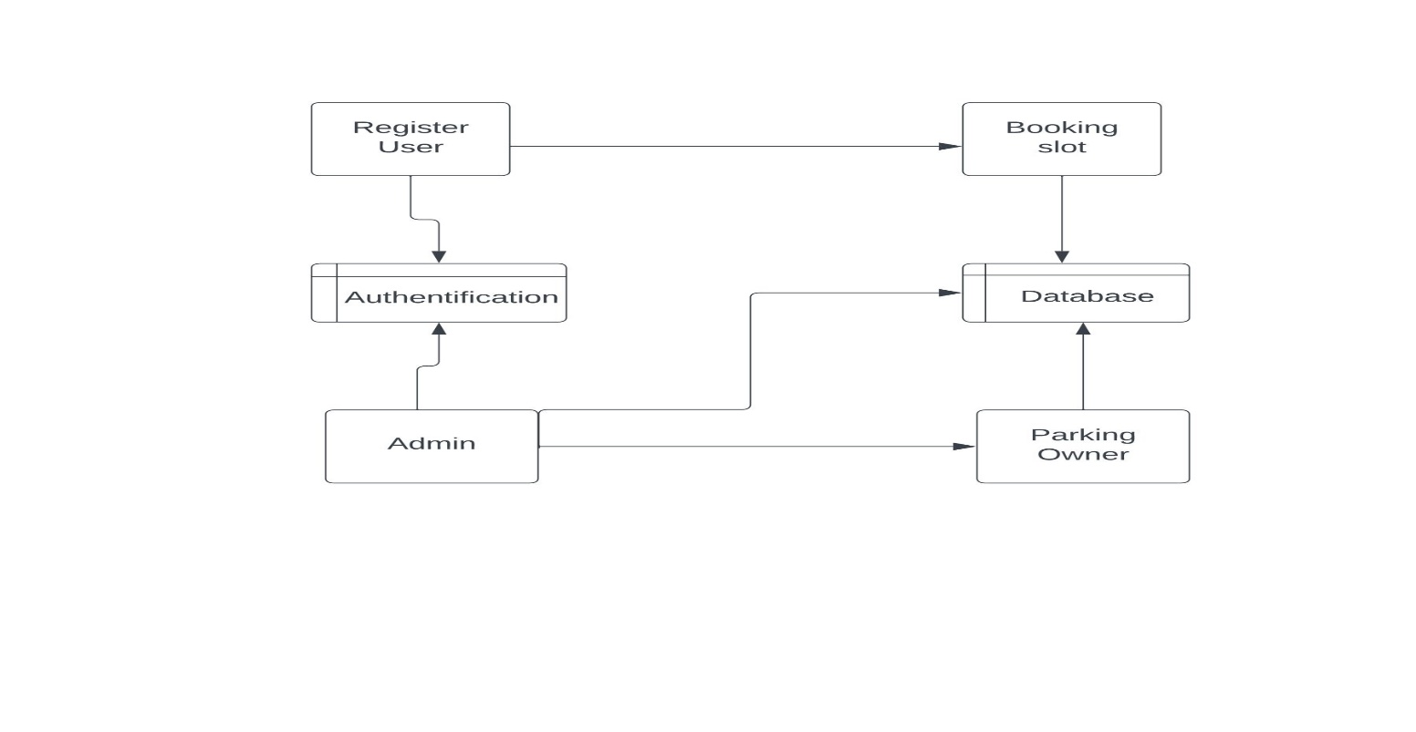

* 1. Entity Relationship Diagram

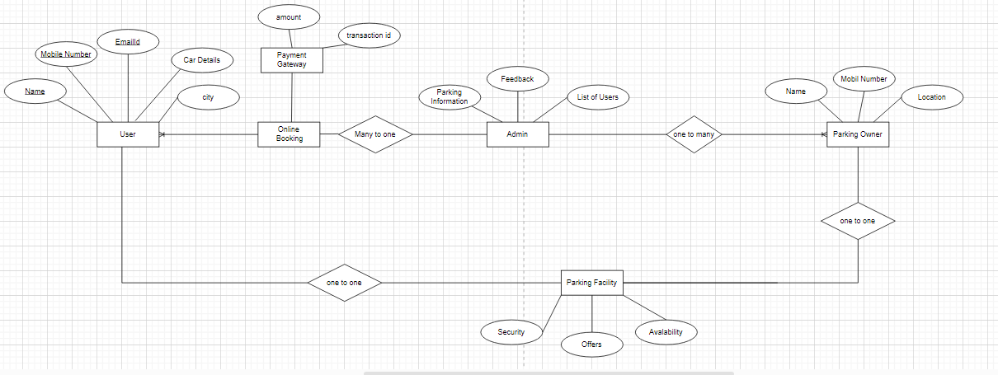

1. Use Case Diagram

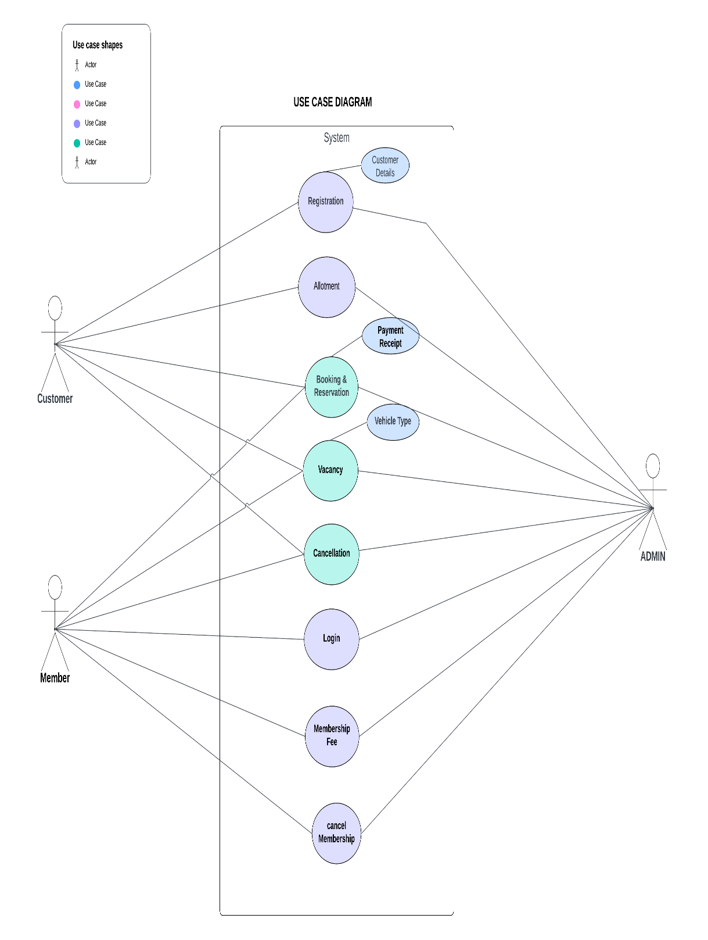

Classes Diagram

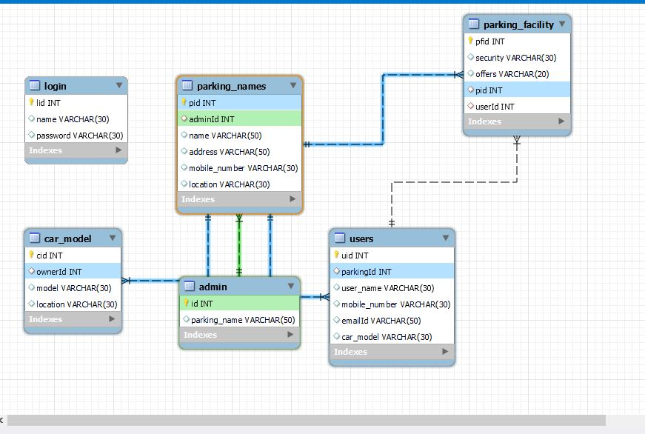

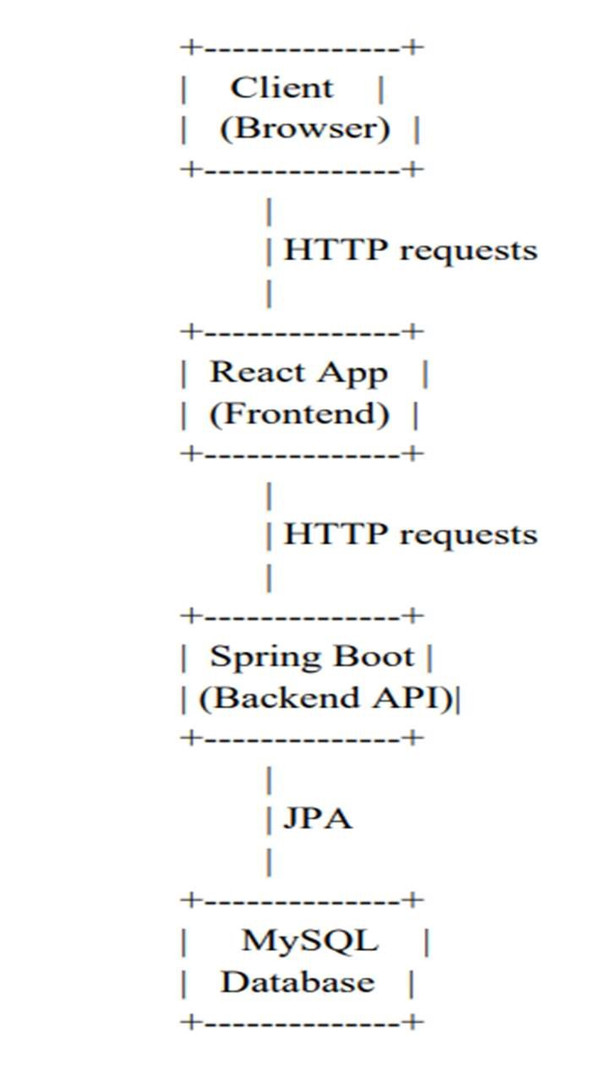

1. Application Screenshots

* Version Control and Collaboration:

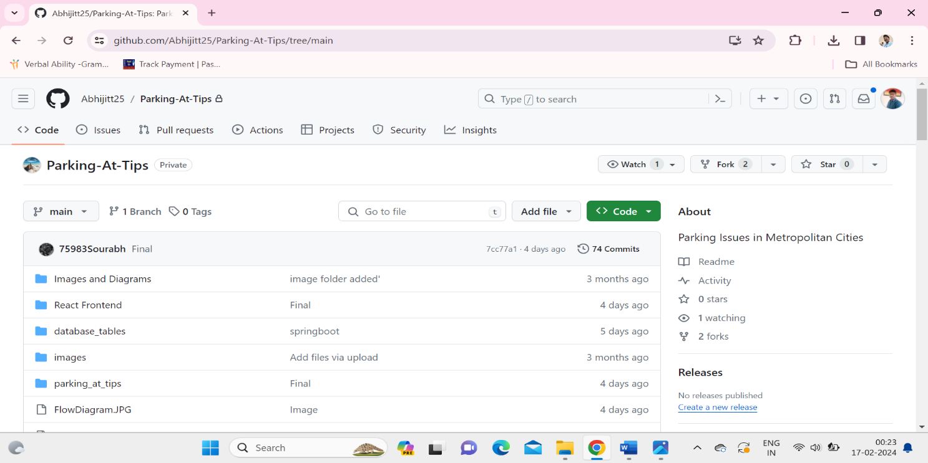

* Home Page

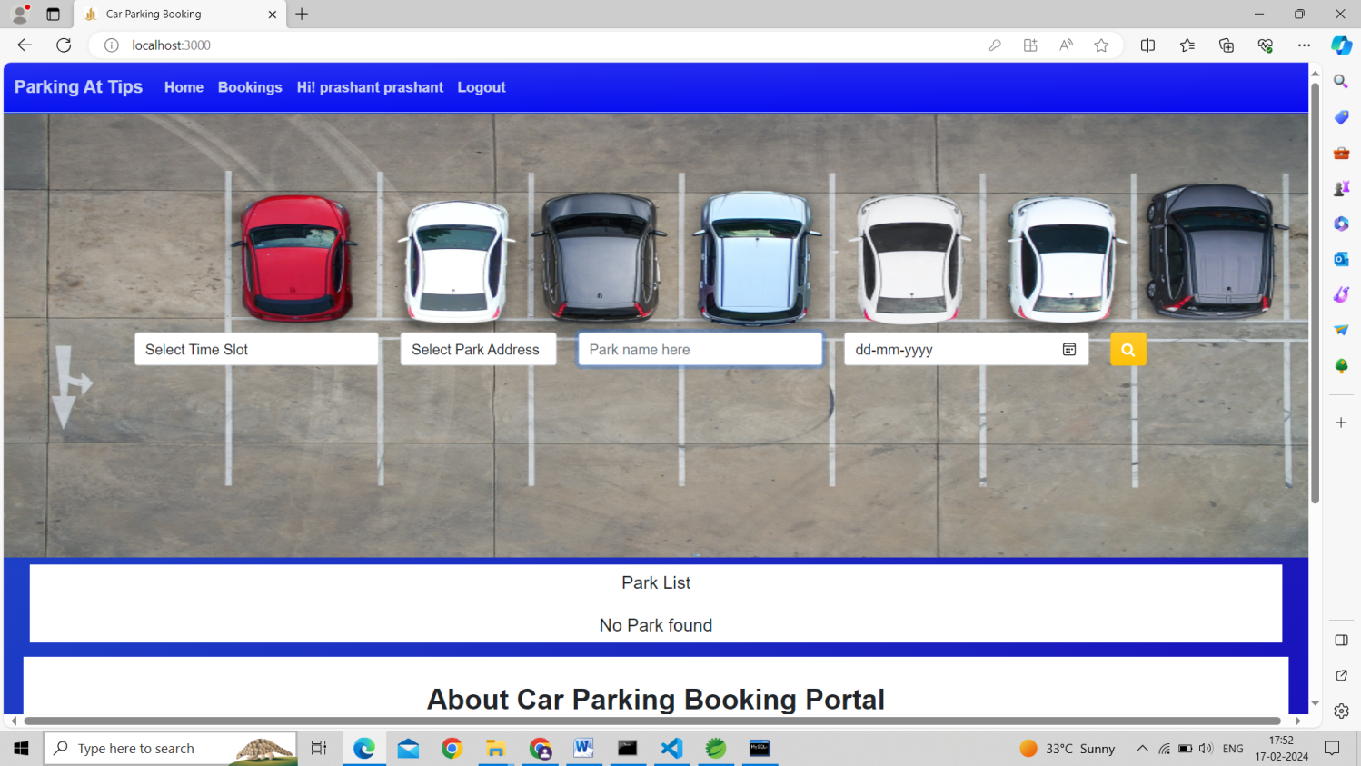

* Admin login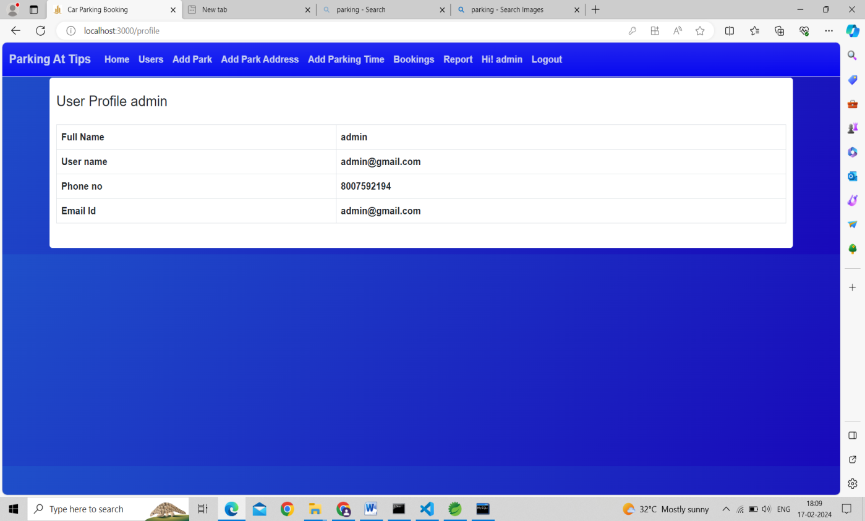

* UserProfile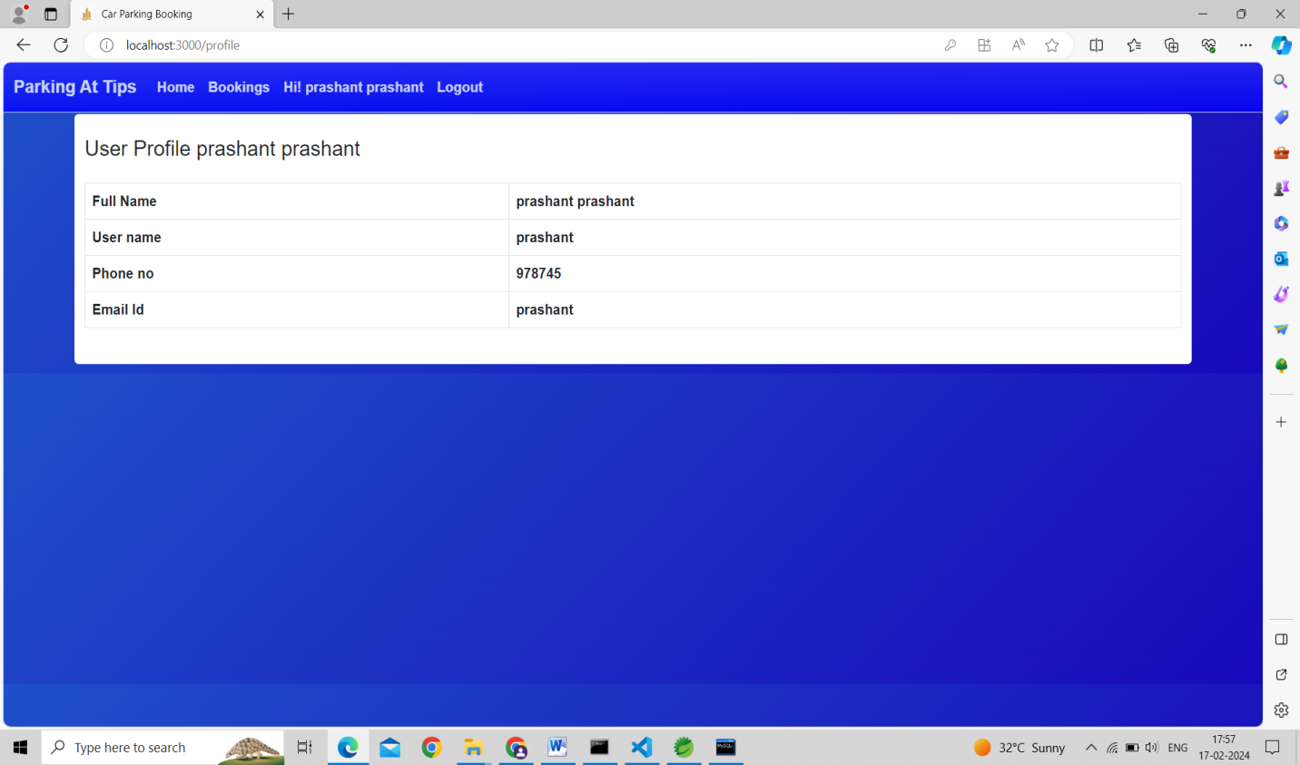
* Booking_Page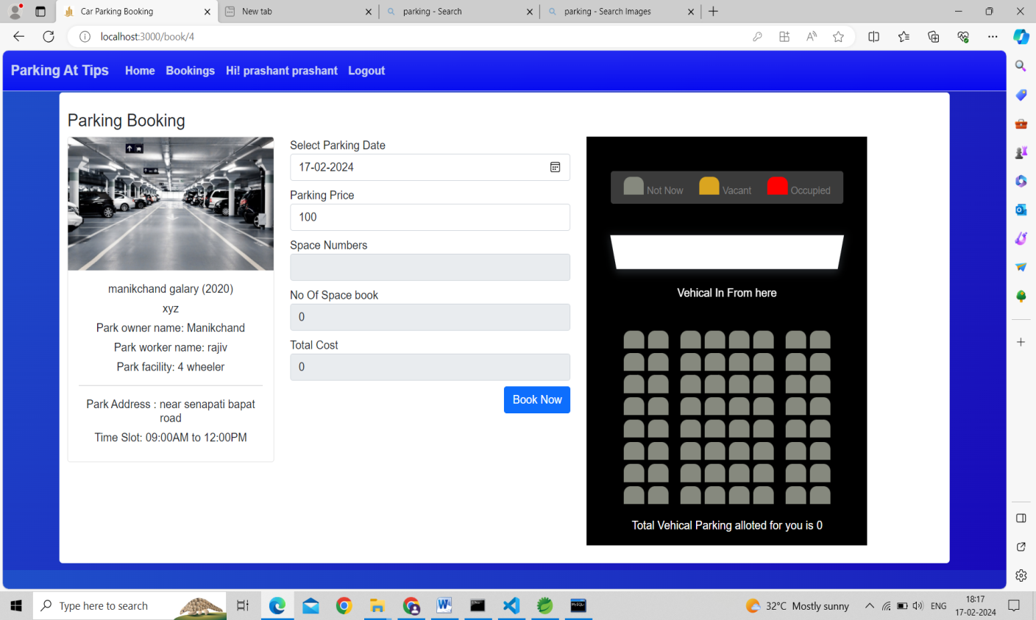

* Booking Sussefull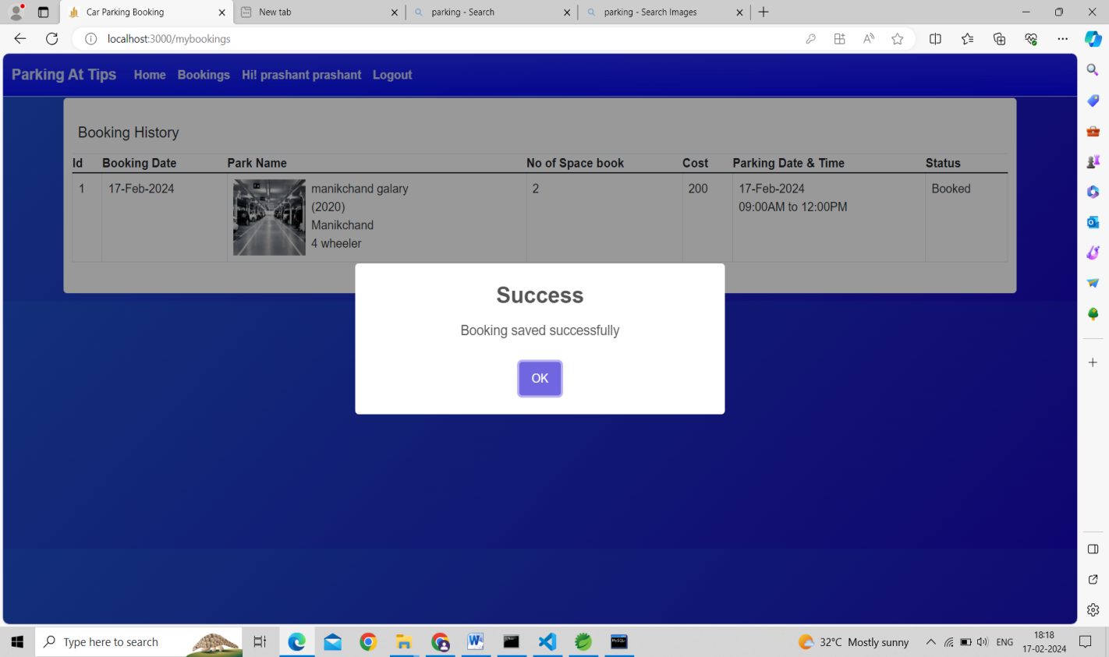

8. References

|  |
| --- |
| M. A. R. Sarkar, A. A. Rokoni, M. O. Reza, M. F. Ismail, “Smart parking system with image processing facility”, I. J. Intelligent System and Application, 41-47, 2012. |

1.

2. D. J. Bonde “Automated car parking system commanded by android application” in Proc.

Conf., 03- 05, Jan 2012.